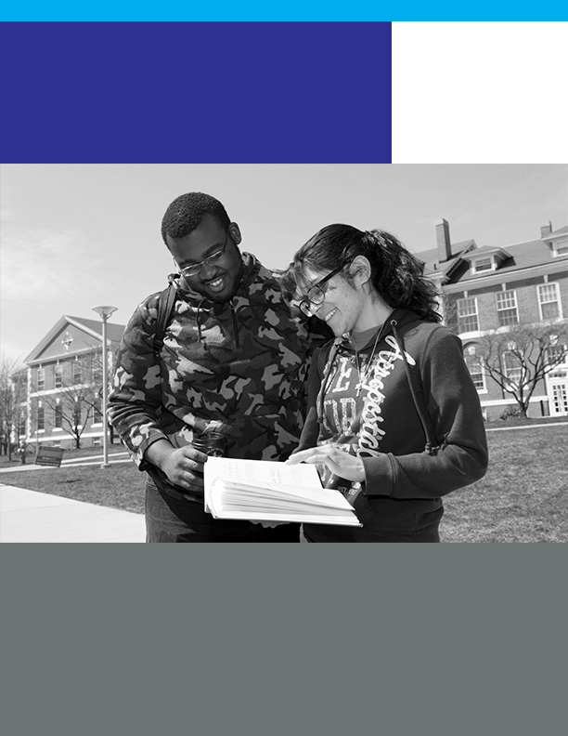
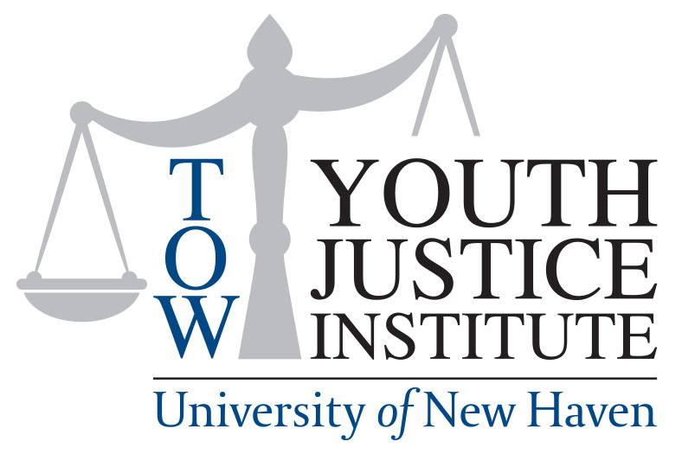

Tow Youth Justice Institute
2021 – 2024 Strategic Direction
Sustaining Our Future

Table of Contents

Page
- Staff Planning Process 3
- 2019 – 2021 Goal Achievements 3 - 11
- Updated Strategic Direction 12 - 19
- Organizational Structure 20
- Budget 21
- Plan to Sustain Operations 22
- Gratitude to our funders and collaborators 23

- Staff Planning Process

In 2018, staff embarked on a strategic planning process that identified our mission, vision, and values, and outlined our primary goals and objectives for 2019 – 2021. As we moved into our sixth year of operations, we concluded that we needed to develop a sustainability plan that would take us through the next five years, and an update to our strategic direction as the plan expired in 2021.

We began the process with the sustainability plan. Not receiving the capacity-building funding we pursued, we moved on with utilizing faculty and students in the College of Business Masters class. The assignment was given to them in January 2020, and they completed and presented their sustainability plan to us in May 2020. Staff began reviewing the students’ plan in July 2020 for feasibility and alignment. We began a process of developing five-year financial projects to sustain the work outlined in the current strategic plan. In September 2020, we engaged our Advisory Council in a planning session to get their input and feedback. We completed the projections in December 2020 and began staff planning sessions in January 2021 with a self-assessment visioning survey that was completed by all staff (with the exception of one staff who was on leave).

Staff completed a detailed accomplishments document for their area of work based on a review of the 2019 – 2021 Strategic Plan. The staff planning sessions consisted of reviewing the results of the self-assessment survey on the Institute’s work, communication priorities, reviewing the mission statement, professional development and team building, racial justice, the role of the advisory council, and staff roles and responsibilities.

- Achievement of 2019 – 2021 Strategic Goals

We are proud of the accomplishments we’ve made toward our stated goals in 2019 and the expansion of our work since then.

GOAL #1 - Research and Evaluate Youth Justice Issues in Order to Advance Data-Driven Policies and Practices
Collaborate with Institutes of Higher Education conducting research on JJ
- Collaboration with IMRP at CCSU, and UConn on public hearings focused on youth and young adult voices to inform the work of the Police Transparency and Accountability Task Force
- Collaboration with SEICHE Center for Health and Justice at Yale University on hosting a research-focused event as part of the SEICHE Spring 2021 Seminar Series.

Collaborate with Private Organizations conducting research on JJ
- Partnership with Clifford Beers to provide JJ expertise for the Embrace (CT InCK) aimed at achieving health equity through improving the quality of care for children and pregnant individuals eligible for Medicaid and CHIP, especially those with or at-risk for developing significant health or mental health needs, and exposure to adverse childhood experiences
- Partnership with the CT Justice Alliance on vision sessions and public events

Work to expand cutting-edge youth justice curriculum content and learning opportunities for students
- The Seminar in Youth Justice and Exploring Delinquency classes was launched in 2020, completing the release of classes updated for the Juvenile Justice and Delinquency Prevention Concentration.
  - The seminar is a capstone course that exposes students to a wider array of topics affecting the youth justice system, allowing for a more nuanced conversation about youth justice.
  - Exploring Delinquency is a service-learning course focused on students working together to identify solutions aligned with the calls to action through in-class discussions and presentations, as well as by planning and hosting community conversations on various topics.
- Youth Injustice and the Kalief Browder Story course was expanded to different modes of teaching—from full asynchronous to in-person, to online with synchronous meetups. This class has been taught at the undergraduate level and also expanded to offer a separate section for graduate students.

Target students, faculty, and even community members to attend and participate in youth justice learning and discourse opportunities
- A Summer New Haven Social Justice School program prompted the creation of a focus group of students, where their thoughts and input would lead to discussions of change in juvenile justice work. There was a round table following the Summer New Haven Social Justice School where the students involved could voice their likes and dislikes of the program, discuss possible troubleshooting to improve the next program, and share their personal benefits from the program. Students who did not participate in the Summer Justice School were also invited to participate in the roundtable, and Dr. Cooper’s research team facilitated and led the discussion questions.
- On November 13th the University of New Haven, via the Tow Youth Justice Institute, partnered with the Connecticut Police Transparency and Accountability Task Force to host a virtual Young Adult Listening Session. The Task Force focuses on addressing and improving police transparency and accountability in the state of Connecticut. This listening session called on the voices of Connecticut residents between the ages of 18 and 25 years old to give public testimony to members of the Task Force about their experiences with law enforcement, opinions of the Police Accountability Bill, or any other criminal justice-related issue that was of importance to them. During the 3-hour listening session, young adults testified on various issues such as police training, traffic stops, and racial and ethnic disparities in the criminal justice system.
- In October, as part of National Youth Justice Awareness Month, Dr. Danielle Cooper developed a trivia event for her students and others at the university to participate in and learn more about youth justice. The trivia was written by students, allowing them to take their readings and assignments from the course and use it for a practical, learning experience.
- Dr. Cooper also enlisted her students to create the Pushout Event, where a viewing of the 2019 documentary film was planned and was followed by a discussion with the students and invited guests. The Pushout film and book played a large part in the CJST 4430 course, and brought attention to the long-standing issue of Black teens, especially girls, being pushed out of public schools due to discrimination of gender and race.

GOAL #2 - Educate Policy Makers, Practitioners, and the Community about Ways to Advance Youth Justice Reform and Achieve Better Outcomes for Youth

Transforming Youth Justice Leadership Development Program
Despite technical challenges in restructuring the Transforming Youth Justice: A Leadership Development Program to a virtual format this year due to the pandemic, we completed the fifth cohort, and 14 more individuals working in various aspects of youth justice graduated and are bringing their skills back to their current professional roles. Graduation speakers this year were the Commissioner of the Department of Children and Families, Vanessa Dorantes, and Markus Cherry, Director of Workforce Development, Career Resources Inc. who discussed his lived experience in and out of the juvenile justice system. Speakers over the time covered by our strategic plan include Tow Youth Justice Institute staff and University of New Haven faculty, state juvenile justice advocates, Connecticut state agencies, previous year cohort graduates, family engagement specialists, data specialists, and non-profit leaders. The number of cohort graduates is now 74.

We are currently in the process of reviewing the program and its curriculum. Some new changes will consist of aligning the 9-month program to be consistent with the academic and fiscal years of the university which will kick off with the start of Cohort #6. Under the guidance of the Director of Training & Prevention Programs, a strong plan is being developed including the development of the Alumni Network.

Connecticut Institute for Youth and Police Relations
Conversations began in 2017 with the Hartford Foundation for Public Giving (HFPG) about our desire to start a police training program that aligned with an area of interest and focus for the foundation. With the support of the Singer Foundation for a planning grant in 2018 (through a referral made by the Tow Foundation), TYJI engaged the Center for Advanced Policing at the university in the development of the training program which became the Connecticut Institute for Youth and Police Relations. The application to the HFPG was completed in early 2020 and they identified another opportunity for support through funds from the Travelers Championship. With funding in place, execution plans began in late 2020, and collaboration for public engagement around community policing was established with Central Connecticut State University. The kickoff to the program marking the first session of the inaugural cohort of police officers from the greater Hartford area took place on Friday, February 12, 2021. A total of 14 officers representing seven units in the Greater Hartford area completed the 8-month intensive in-person training and graduated with a presentation of their Community Engagement Projects in September 2021.

Restorative Practices Training and Technical Assistance
The Restorative Practices training and technical assistance for the School-Based Diversion Initiative (SBDI) at the Child Health and Development Institute of Connecticut (CHDI) have continued this year and contracted trainings are scheduled to be completed through summer 2021. As with our other programs, a lot of focus went into revising the training curriculum to be delivered in an online format. Additional offerings being conducted include online training, remote technical assistance, and remote coaching. Respondents reported that the majority of the staff using restorative practices are support staff such as school psychologists and social workers (37), followed by teachers (33), administrative staff (30), school counselors (29), paraprofessionals (7), school resource officers (6), aides such as classroom, lunch or recess aides (1) and other school staff (5).

The Restorative Justice Practices Project’s engagement with the University of New Haven campus community has grown. Campus partners are collaborating on Restorative discussions, events, training, etc., and Restorative Justice Practice’s resources and services available are being promoted to the campus community through various mediums and departments. Training and presentations have been conducted within the Department of Student Affairs, the Office of Residential Life, and the Henry C. Lee Department of Criminal Justice and Forensic Sciences. An effort has also been made by the Restorative Justice Practices Project to make presentations to undergraduate courses on juvenile justice. Over 150 students on campus have now been exposed to Restorative Justice methodology and practice through our efforts.

In addition, a Fee for Service Plan for technical assistance is being developed to assist in scaling our Restorative Practices training and technical assistance offerings, including identifying services, building a prospective contracted services budget, and identifying additional staffing required to execute additional contracts. To date, 5 contracts have been executed with community partners such as the YWCA of New Britain, the Westport Police Department, and the Connecticut Association of Alternative Schools, with an additional 2 pro-bono contracts having been delivered to the New Haven Public Schools and the Department of Children and Families.

A goal outlined in our 2019 – 2021 Strategic Plan was for the development of a restorative practice “hub” for the state of Connecticut. Two funding opportunities have been identified to support its development. A meeting was held with the CHDI (currently a funder for the school-based restorative training) to discuss the scope of this project. A timeline is in place to begin the development of the hub for an application to the JMK Innovation Prize for the planning phase of this work.

GOAL #3 – Collaborate With Policy Makers, Practitioners, and Community, Especially Youth and Their Families, In Order To Promote and Achieve Multi-System Reform

Council of State Governments (CSG) Improving Outcomes for Youth (IOYouth)
In June 2019, leadership from Connecticut’s three branches of government—Governor Ned Lamont, Judge Patrick Carroll, and Representative Toni Walker – launched the Improving Outcomes for Youth (IOYouth) Statewide Task Force with the goal of assessing whether recent juvenile justice system reforms have been implemented as intended and have had the expected impact. The Task Force’s charge was to determine what next steps are needed to ensure that policies, practices, and resource allocation decisions are aligned with what the research says works to improve outcomes for youth and strengthen public safety. The IOYouth Task Force, co-chaired by Rep. Toni Walker and Sec. Melissa McCaw, Secretary of the Office of Policy and Management, included other elected officials, representatives from all three branches of government, state and local juvenile justice system leaders, and advocates, among others.

Under the guidance of the Task Force, the Council of State Governments (CSG) Justice Center conducted a year-long comprehensive assessment of Connecticut’s juvenile justice system from referral to reentry, including:
- Extensive analyses of case-level juvenile justice and fiscal data;
- Focus groups with stakeholders across Connecticut, such as juvenile justice and other youth-serving agency officials, prosecutors, public defenders, judges, law enforcement, probation staff, community-based providers, advocates, and youth and families; and
- Reviews of state policies, regulations, practices, and resource allocation.

The IOYouth Task Force met several times in 2019 and 2020 to review the CSG Justice Center’s assessment findings and identify data-driven strategies to improve outcomes for youth. In July 2020, the Task Force convened its final meeting and reached a consensus on a broad set of research-based policy recommendations to reduce recidivism and improve outcomes for youth in Connecticut’s juvenile justice system.

An IOYouth Implementation Committee was established as a workgroup of the Juvenile Justice Policy and Oversight Committee (JJPOC) to oversee the adoption and implementation of the IOYouth recommendations. The Implementation Committee is chaired by Rep. Walker, Secretary McCaw, and Gary Roberge, Executive Director of the Judicial Branch Court Support Services Division (CSSD), and includes representatives from the Office of Policy and Management, Judicial Branch, Department of Corrections, Department of Children and Families, the state’s attorney and public defender’s offices, the advocacy community, and a parent and youth representative. The Implementation Committee is responsible for translating the consensus-based IOYouth recommendations into legislative and administrative policy changes for JJPOC approval, as well as providing feedback to the Judicial Branch and Department of Children and Families on agency policy changes resulting from the IOYouth initiative.

JJPOC Workgroups
The past year has been a grueling one for supporting the work of the JJPOC. The number of workgroups, sub workgroups, and committees expanded significantly (20 in total) and the intense year-long assessment by the Council of State Governments was completed. These groups include:
- Diversion (Raise of the minimum age Subgroup, Truancy Subgroup, FWSN Subgroup)
- Racial and Ethnic Disparities (Community Policing Subgroup, School Resource Officer Subgroup)
- Incarceration (Reentry and Wraparound Services subgroup, MYI/YCI Subgroup)
- Education Committee (Quality Control Subgroup, Infrastructure Subgroup, Reentry Subgroup)
- Community Expertise Workgroup (Parent/Community Expertise Subgroup, Youth Expertise Subgroup)
- Cross-Agency Data Sharing (Auto-theft subgroup)
- IOYouth Task Force

In addition, after convening 3 separate subgroups focused on different aspects of the education system, the Education Committee launched a reform plan to roll oversight of educational services in all levels of the JJ system under the Department of Children and Families.

Expansion of TYJI staff role
Our work supporting the JJPOC expanded to provide research tasks to fulfill requests made by the JJPOC and its workgroups. We engaged content experts including the State of Connecticut Judicial Branch Court Support Services Division, Office of the Child Advocate, Connecticut Voices for Children, and the Center for Children’s Law and Policy on the following topics:
- National and international research on the minimum age of juvenile jurisdiction
- School resource officers and impact on youth, especially minority youth
- Racial and ethnic disparities in CT
- Deep dive into RED by the Cross agency data sharing workgroup
- CT suspensions and expulsions
- Impact of chemical agents on youth and alternative strategies
- Pedestrian stop laws and definitions across the country
- Juvenile transfer laws and state models for housing adult-charged youth
- Deep dive into Families with Service Needs status offense changes

A JJPOC orientation manual has been developed and is distributed to all new members on an ongoing basis. This manual provides a comprehensive overview of the committee, its workflow, organizational structure, membership, voting process, and more.

The 2021 JJPOC recommendations and those made by the JJPOC workgroups, executive committee, community expertise workgroup, and the IOYouth Task Force (CSG assessment), which included the recommendations made in 2020, were drafted and submitted under HB6667. The 2020 JJPOC proposed recommendations were not moved forward as the legislative session was canceled due to the pandemic.

GOAL #4 - Engage University of New Haven Students in Ways That Provide Personal and Professional Development Opportunities to Support the Formation of a Future Workforce through Strong, Innovative Youth Justice Educational Programs

Student Interns
Since the spring semester of 2019, TYJI has had 45 interns and 20 Research interns who worked on each segment of our work including restorative justice, policy, communications, and research.
Promote and Support Campus Leadership opportunities

- The JJ Club was established
- Accepted interns from program evaluation class
- Several students completing internship required for graduation
- Students took leadership of TYJI 5-year anniversary event on campus
- A masters level class capstone project focused on the sustainability of TYJI
- A bachelors communication class developed a social media plan

Curriculum
Work to expand cutting-edge youth justice curriculum content and learning opportunities for students.
- The Youth Injustice and the Kalief Browder Story course was implemented and the Justice Advisors of the Connecticut Justice Alliance were engaged in the Exploring Delinquency class in fall 2020.

GOAL #5 - Become a Valued Content Expert and Resource in the Field of Youth Justice in the State and Nation

Development
Establish new funder relationships for operational and project support. At least 2 -3 new funders to leverage the Tow Foundation investment will be secured by 2021.
- Hartford Foundation for Public Giving/Travelers
- 2019 OJJDP Cooperative Agreement

Utilize connections and knowledge of Advisory Council members to advance TYJI mission and goals
- Held meetings 3 times/year
- Held planning session in fall 2020
- Have continued relationships with FCCF, HFPG, Perrin, Dalio, and A. Bivens (previously with FCCF, now with Tremaine)

Connect with other organizations funded by the Tow Foundation to explore mutual interests
- We have working relationships with CCLP, Clifford Beers, Community Partners in Action, Connecticut Justice Alliance, Justice Policy Institute, Partnership for Strong Communities, and RYASAP.

Implement and manage the Office of the Juvenile Justice and Delinquency Program (OJJDP) and other federal grants
- TYJI received $431,000 from the 2018 OJJDP Cooperative Agreement for a RED Reduction Program, Community-Based Diversion Implementation, and Evaluation with sub awardees CCA and CYSA and is entering its third year of implementation May 1st, 2021. This Cooperative Agreement with the OJJDP was awarded in October 2018 however, it is being implemented in 2019 – 2021.
- The 2019 OJJDP Cooperative Agreement for $434,575 Addressing Racial and Ethnic Disparities through Local and Statewide Strategies began February 1, 2021, with sub awardees CCLP and RYASAP
- We have applied for the 2020 – 2021 OJJDP NPS Cooperative Agreement funds for $1,046,559 for “Restoring Connecticut youth in and out of the juvenile justice system” to develop our initiative, A Restorative Place, to conduct a landscape analysis with the Connecticut Youth Services Association, and a Deep End Diversion Project at Connecticut Detention Centers with the Center for Children’s Advocacy.

Explore other Sources of Funding
- Andrus Family Fund for Integrating Community Expertise
- Smith Richardson – Georgetown RP
- Community Foundation for Greater New Haven – capacity building for sustainability planning
- Singer Foundation – Implementation of CIYPR
- Connecticut Health Foundation
- W T Grant
- Applying to JMKaplan
- Will apply for the 2021 OJJDP Cooperative Agreement

Communications
Marketing campaigns for the following:

The work of the JJPOC and its four goals for 2019 - 2021
- Developed communications to facilitate understanding of the 2019 and 2021 JJPOC Legislative Recommendations and raise public awareness of issues that support the proposed legislation.
- In 2021, a legislative package was developed. Moving forward the legislative package will be done annually.
- Support other JJPOC work such as events, forums, and other communication needs including the three-part webinar series Fact vs. Fiction, 10 year anniversary of Raise the Age, the announcement of the Council of State Governments IOYouth project, and proposed 2021 legislation.

Transforming Youth Justice Program
- Provided communications support to recruit cohorts and assist with graduation needs, including the development of videos.

Student Events and Student Leadership
- Assisted with development of JJ Club logo
- Worked with students on planning the 5 year anniversary event
- Worked with two undergraduate classes on social media plans
- Worked with a graduate class capstone on developing a sustainability plan
- Promoted the good work of students through our website

Connecticut Institute for Youth and Police Relations
- Created recruitment materials, application, brochure

Become a respected content expert
- Since 2019, produced 9 Issue Briefs
- Collaborating content on 6 Issue Briefs with community organizations

Become a resource for community partners to gain knowledge about changes in the youth justice system
- Another way in which we are educating the public and raising awareness of the issues facing youth is through our brand new website. We are excited about how we are promoting our work, our strategic direction, our partners, our students, our team, and our accomplishments.

- TYJI 2021 - 2024 Strategic Direction

As an outcome of the staff visioning and planning sessions, we have developed an updated mission and vision, and have updated our value statements:

Mission
The Tow Youth Justice Institute at the University of New Haven was established to lead the way for youth justice reform through the engagement of policymakers, practitioners, service providers, students, communities, youth, and their families. The TYJI works to promote the use of effective, data-driven practices, programs, and policies related to youth justice, focusing on the needs and wellbeing of youth up to the age of 24.

Vision
Our vision is for a state in which those serving youth are consistently using best practices to create positive opportunities so that our children, families, and communities are safe, healthy, and resourceful environments. We envision our future being sustained through the collaboration of university, state, and private partnerships.

Values
We believe that:
- Only through cross-system collaboration and transparency can we achieve true system reform.
- Critical discourse is imperative to hold systems accountable for change.
- Authentic engagement and voice are needed from youth, their families, and the community to raise awareness of the issues related to reforming the juvenile justice system.
- Long-term commitment is required from all stakeholders and funders to sustain and grow our vision.
- Intentional reliance on research is key to defining reform.
- Youth and families, with appropriate supports and interventions, have the ability to recover and change.
- Our work must always be carried out with a lens toward racial justice.

Our strategic direction for the coming years will be organized as follows.

Prevention Programs & Training - Educate Policy Makers, Practitioners, and the Community about Ways to Advance Youth Justice Reform and Achieve Better Outcomes for Youth
The Tow Youth Justice Institute will implement leadership training for those working in the youth justice field, enhance police-youth relations through training, and promote and innovate Restorative work in all youth-serving systems in the state.

Policy - Collaborate With Policy Makers, Practitioners, and Community, Especially Youth and Their Families, In Order To Promote and Achieve Multi-System Reform
The focus for multi-system reform will be driven by the recommendations and work of the Juvenile Justice Policy and Oversight Committee and its workgroups.

Research - Research and Evaluate Youth Justice Issues in Order to Advance Data-Driven Policies and Practices
The Tow Youth Justice Institute will coordinate qualitative and quantitative research projects focused on youths and young adults to inform key stakeholders in their decisions about reform utilizing faculty and staff at the University of New Haven, as well as other private organizations and institutions of higher education.

Marketing - Become a Valued Content Expert and Resource in the Field of Youth Justice in the State and Nation through communications and development of resources
The Tow Youth Justice Institute will become a model of best practices by expanding communications of knowledge and resources in the youth justice field to and with key stakeholders in the state and nation.

Student Engagement - Engage University of New Haven Students in Ways that Provide Personal and Professional Development Opportunities to Support the Formation of a Future Workforce through Strong, Innovative Youth Justice Educational Programs
The Tow Youth Justice Institute will promote and provide opportunities for students to participate in internships, volunteer opportunities, research, and student events, and become a national model for other universities on student engagement.

Training & Prevention Programs

Key Functions:
- Train youth justice reformers in juvenile justice system reform, 21st Century policing techniques, and those working to divert youth from the juvenile justice system through a restorative approach to responsibility and healing.
- Lead a statewide movement, with an eye toward a national model, of a Restorative Collaborative which will provide opportunities for resource-sharing, collaboration, and support between members of the Connecticut Restorative community.

Transforming Youth Justice Program
Undergoing evaluation to focus the program and training. New name forthcoming. Will take on a more restorative approach.
- Annually graduate 15 cohort members who can increase the impact of the program through the reach of participants within their professional roles. Each year, the following activities are ongoing:
  - Facilitate current cohort Leadership sessions
  - Secure presenters and organizational collaborations
  - Review and evaluate program curriculum and session schedule
  - Revise content, process, and schedule for next session
  - Oversee the production of program evaluation report

- Establish a strong Alumni Network to provide cohort graduates with ongoing support and access to resources through collaborative learning communities, involvement in leader/alumni mentorships, continued participation in support of newer cohorts, and ability to build collaborations and networks across branches of governments, service providers, agencies, advocacy groups, etc. Activities will include:
  - Hosting alumni network events
  - Developing an Alumni communication plan

Restorative Practices Training and Technical Assistance
TYJI will develop innovative Restorative Justice programming, training, technical assistance, and implementation support for communities across the state of Connecticut. Through these activities, the RJPP will strengthen community ties, increase our network, incorporate Restorative methodology throughout the University of New Haven campus and begin a robust spectrum of contracted services throughout the state.
- Provide Restorative Practices training and technical assistance for the School-Based Diversion Initiative (SBDI) at the Child Health and Development Institute.
  - Our goal under the SBDI contract is to effect positive outcomes for Connecticut’s school districts most at-risk for juvenile justice involvement. To accomplish this goal, we work to increase knowledge and understanding of Restorative Practices and Restorative theory within school populations, foster the implementation of Restorative practices within school settings, increase positive school climate through nurturing Restorative relationships, and reduce in-school suspension, out-of-school suspension & school-based arrests through Restorative responses to behavioral problems.

- Develop a Restorative Collaborative for Connecticut with key players (practitioners, researchers, program managers, etc.) in Restorative Justice/Restorative Practices work within the state of Connecticut
  - The Restorative Collaborative will provide opportunities for resource-sharing, collaboration, and support between members of the Connecticut Restorative community. Within the context of a Restorative methodology, we will work together to develop a meaningful and strategic plan for the Restorative Hub at TYJI, so that all members of the Connecticut community can have access to Restorative practices. We plan for this state-level Restorative Collaborative to meet regularly by 2022 and to develop our Project and Implementation Plan upon receipt of funding.

- Strengthen sustainability of the Restorative Justice Practices Project through engaging the University of New Haven campus community and increasing project capacity through contracted work. This will be done by:
  - Strategically identifying campus partners (ex: Student Affairs) to collaborate on Restorative discussions, events, training, etc.

- Strengthen sustainability of the Restorative Justice Practices Project by increasing project capacity through contracted work. This will be done by:
  - Outreach to community partners throughout Connecticut for training, events, and other opportunities

Connecticut Institute for Youth and Police Relations
CIYPR staff and researchers will continue the data collection and analysis for the process and impact evaluation of the program. In addition to students and faculty from the Research Team, and additional collaboration with students of the Program Evaluation course from the Psychology Department will expand the evaluation capacity. The evaluation will assess the processes related to building infrastructure, recruiting participants, training and educational session, and technical assistance. Additionally, data collected after each session and pre/post-test will inform the impact that the officers experienced during the 8-month training. Additional data will be collected from the community to determine their awareness, support, and concerns related to the Community Engagement Projects being implemented. Through these activities,
- Complete evaluation of process and impact for the onboarding and training through September 2021.
- Collect data from key stakeholders in the Greater Hartford area, and in other parts of the state that could be future sites for cohorts.
- Support the sustainable implementation of the seven capstone projects that have been proposed by CIYPR graduates.

Policy
The focus for multi-system reform will be driven by the recommendations and work of the Juvenile Justice Policy and Oversight Committee and its workgroups.

Key Functions:
- Work with the Juvenile Justice Policy and Oversight Committee on an ongoing basis for the purposes of advancing reform in the juvenile justice system.
  - Every January the workgroup Co-Chairs present a draft of JJPOC Legislative Recommendations to the JJPOC. They also provide an annual report out to JJPOC in November of each year on progress against its strategic goals. The sub workgroups meet monthly/as needed to accomplish the strategic goals of the workgroup.

- Organize training and educational forums for legislators, stakeholders, and community on identified JJPOC recommendations and/or passed legislation
  - To execute this, there will be bi-annual public educational/informational forums at the Capitol. Topics will focus on current issues in juvenile justice or major releases of information or research. The expectation is to increase the number of individuals attending and expand knowledge and understanding of the JJ system and reforms taking place in the state. We will also measure the number of legislators, stakeholders, and community members that participate in the forums.

- Collaborate with the JJPOC to identify areas of focus for TYJI/UNH research that will guide the direction of JJPOC legislative recommendations
  - This will include distinguishing the need for full-scale research studies or general research on topics for a deeper dive.

- TYJI will work with the JJPOC to update their strategic plan as needed.

Research
The students and faculty researchers at TYJI, under the direction of the Director of Research, will continue to examine relevant research questions that are raised by the JJPOC and through other venues. This work is intended to promote understanding of youth justice broadly and provide opportunities for students to participate in research, policy reform, and advocacy effort around the state.

Key Functions:
- Examine research topics of relevance to the youth and young adult population in Connecticut and Nationally
- Provide exposure to and be a resource for students wanting to explore research on youth justice or policy issues.
- Support researchers from other institutions and organizations, and collaborate and access data to inform JJ research
- Support JJPOC committees and subcommittees with research and relevant information to their decision-making
- Translate research into actionable knowledge for key stakeholders and community members who may not feel familiar with research and policy reform efforts

Marketing
The Tow Youth Justice Institute will become a model of best practices by expanding communications of its knowledge and resources in the youth justice field to and with key stakeholders in the state and nation.

Communications
Through a variety of communication channels focused on relevant topics relating to youth justice, the juvenile justice system, community resources and activities, educational opportunities, and public awareness campaigns will be executed internally for students, faculty, and staff at the University of New Haven and externally to multiple audiences and stakeholders.

Key Functions:
- Being broadly recognized as a respected content expert
- Raise public awareness of all TYJI programs and projects
- Become a resource for community partners to gain knowledge about changes in the juvenile justice system
- Become a voice to support JJ reform in our state and beyond
- Provide visibility and recognition for Partners in our youth justice journey
- Interact with media on articles, op-ed, inquiries
- Public forums and event planning and coordination
- Engage the general public through communications on critical JJ topics

Promote the work of Training and Prevention Programs through:
- Materials to expand the Transforming Youth Justice Program outreach every year.
- Various communication channels to expand Transforming Youth Justice Program Alumni Network
- Raise awareness of Restorative Practices training and technical assistance opportunities
- Raising awareness of Restorative Justice resources and services on the University of New Haven campus.
- Working on the development of the Restoring Connecticut project.
Raise awareness of Policy work through:
- Various communication channels for annual
  - JJPOC activities
  - JJPOC recommendations
  - JJ legislation
  - Training and educational forums for legislators, stakeholders, and community
- Develop annual Legislative Package
- Editing and design of all JJPOC publications

Provide Communications support to the Research Department through:
- Editing and design of final research studies
- Raising awareness of key research findings through various channels

Provide Communications support for Student Engagement through:
- Create materials and communications to support outreach on campus for student events and student leadership
- Engaging and establishing relationships with students enrolled in the Juvenile Justice and Delinquency Prevention Concentration through e-communications
- Sharing of information and event notification through UNH internal communication

Through the TYJI’s multiple programs and the myriad of collaborators, it holds a breadth of knowledge to be shared with others and will:
- Continue to identify key issues for briefs
- Collaborate with community organizations on content
- Continue network with national juvenile justice organizations to cross-communicate content for their newsletters, blogs, social media, and websites.
- Continue to be a resource for community partners about changes in the juvenile justice system
- Partner with community-based programs and advocates to raise awareness of common goals and objectives

Primary communication channels will be:
- Website resources, reports, research, and content
- Blogs
- Videos
- Events and webinars
- eNews briefs
- Issue Briefs
- Quarterly newsletters
- Social Media

Development
Development objectives for the TYJI will allow for the completion of the updated strategic direction for 2021 - 2024. Development goals will change each year to reflect other institutional objectives and funding needs. In addition, we will look for ways to collaborate with and pursue funding for large-scale impact opportunities.

Key Functions:
- Execute the key strategies identified in the sustainability plan detailed later in this report.
- Establish new funder relationships for TYJI operational, projects, programs, and events
- Explore Sources of Funding at the University of New Haven
  - As an Institute of the University of New Haven, we will explore other viable sources of fundraising including online giving, individual donors, endowment funding, and sponsorships.

- Implement and manage the 2018, 2020, and 2021 Office of the Juvenile Justice and Delinquency Program (OJJDP) Cooperative Agreements and other federal grants.
- Explore funding opportunities for project collaborations.
- Utilize connections and knowledge of Advisory Council members to advance TYJI mission and goals

Student Engagement
The Tow Youth Justice Institute will promote and provide opportunities for students to participate in internships, volunteer opportunities, research, and student events, and become a national model for other universities on student engagement.

Key Functions:
- Expand internship opportunities to increase students’ knowledge on careers within the Youth Justice field
- Provide exposure to and be a resource for students to our partners working the JJ field.
- Provide an opportunity to work on specific TYJI projects and programs
- Identify faculty, staff, advisors, or student clubs/orgs for possible opportunities for collaboration (For example: Myatt Center on Diversity, Institute of Social Justice, Nonprofit Institute, etc.)
- Student Events that further the knowledge base of youth justice and juvenile justice subject matter and reform efforts, statewide and nationally will establish the TYJI’s presence and visibility on campus as collaborators, supporters, sponsors/hosts of events, programs and conferences.

- Organizational Structure

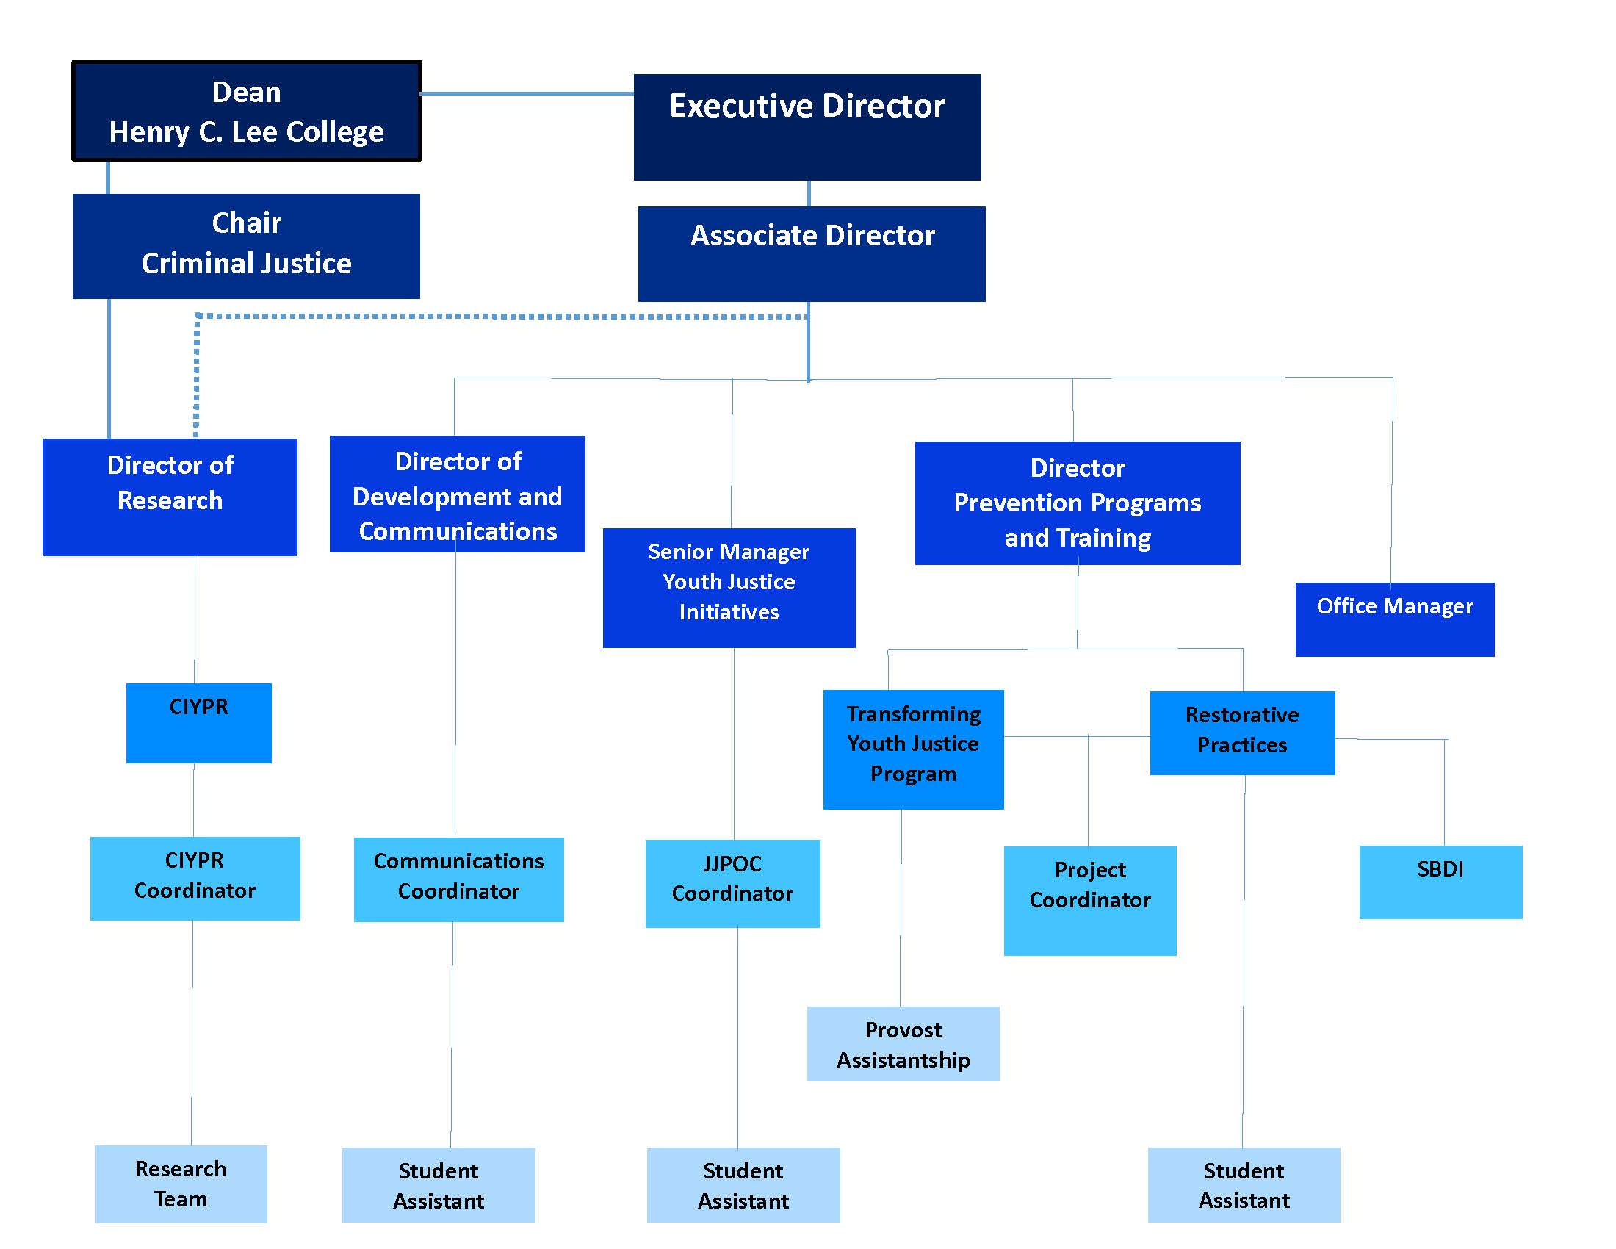

- Budget
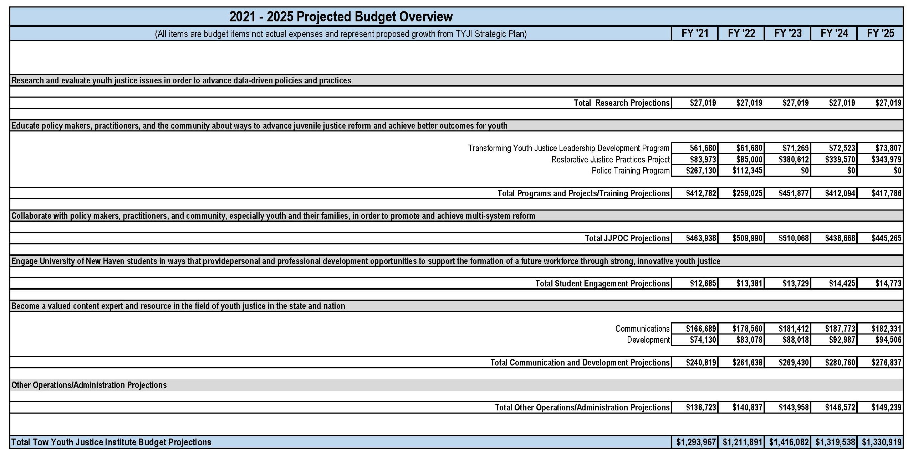

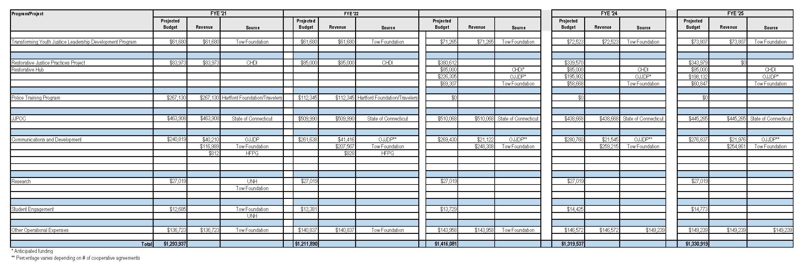

- Sustainability Plan
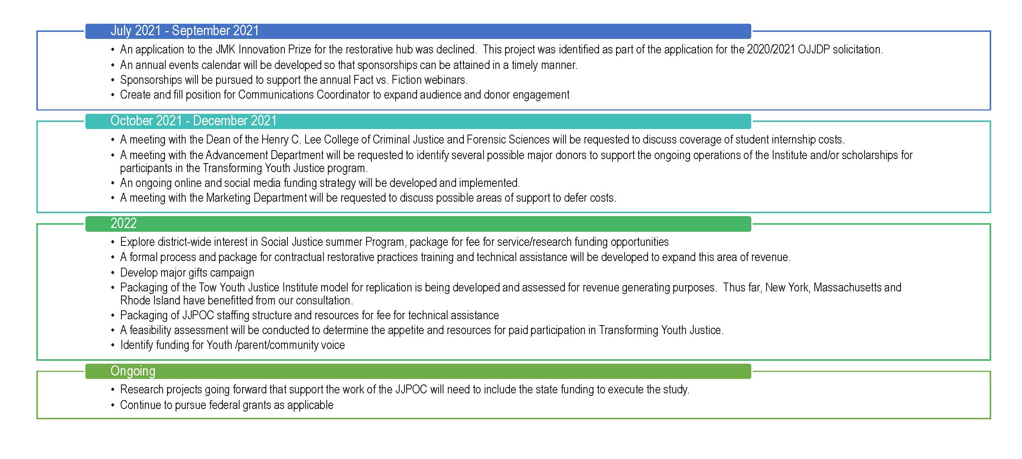
- Plan to Sustain Operations

- Utilization of Tow Foundation Funding
The Tow Foundation Grant expires in June 2024. Utilization of the remainder of the funds are detailed above and include:
- Transforming Youth Justice Program
- Communications and Development
- Student Engagement
- Operational Expense

- Project Funding
It is anticipated that current project funding will continue for the following areas:
- Restorative Practices SBDI
- JJPOC

- Programs and Projects Contingent on Funding
- Development of a Restorative Practices statewide collaborative
- Research Projects
- Continuation of the Police Training Program

- Gratitude to our funders and collaborators

Since the 2014 inception of the Tow Youth Justice Institute and its founding partners, the Tow Foundation, the Henry C. Lee College of Criminal Justice and Forensic Sciences at the University of New Haven and the State of Connecticut, the work outlined in our accomplishments, and the work highlighted in our 2021 – 2024 strategic direction would not be possible without significant support and collaboration. Any omissions are not by design and we apologize if they exist.

Founding Partners/Funders
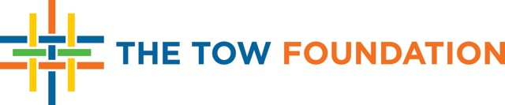
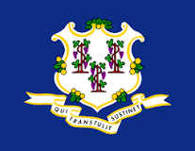


University Partners
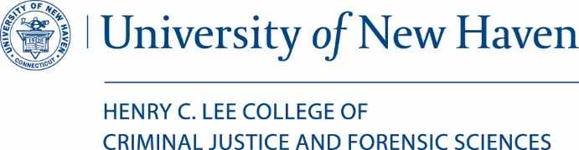
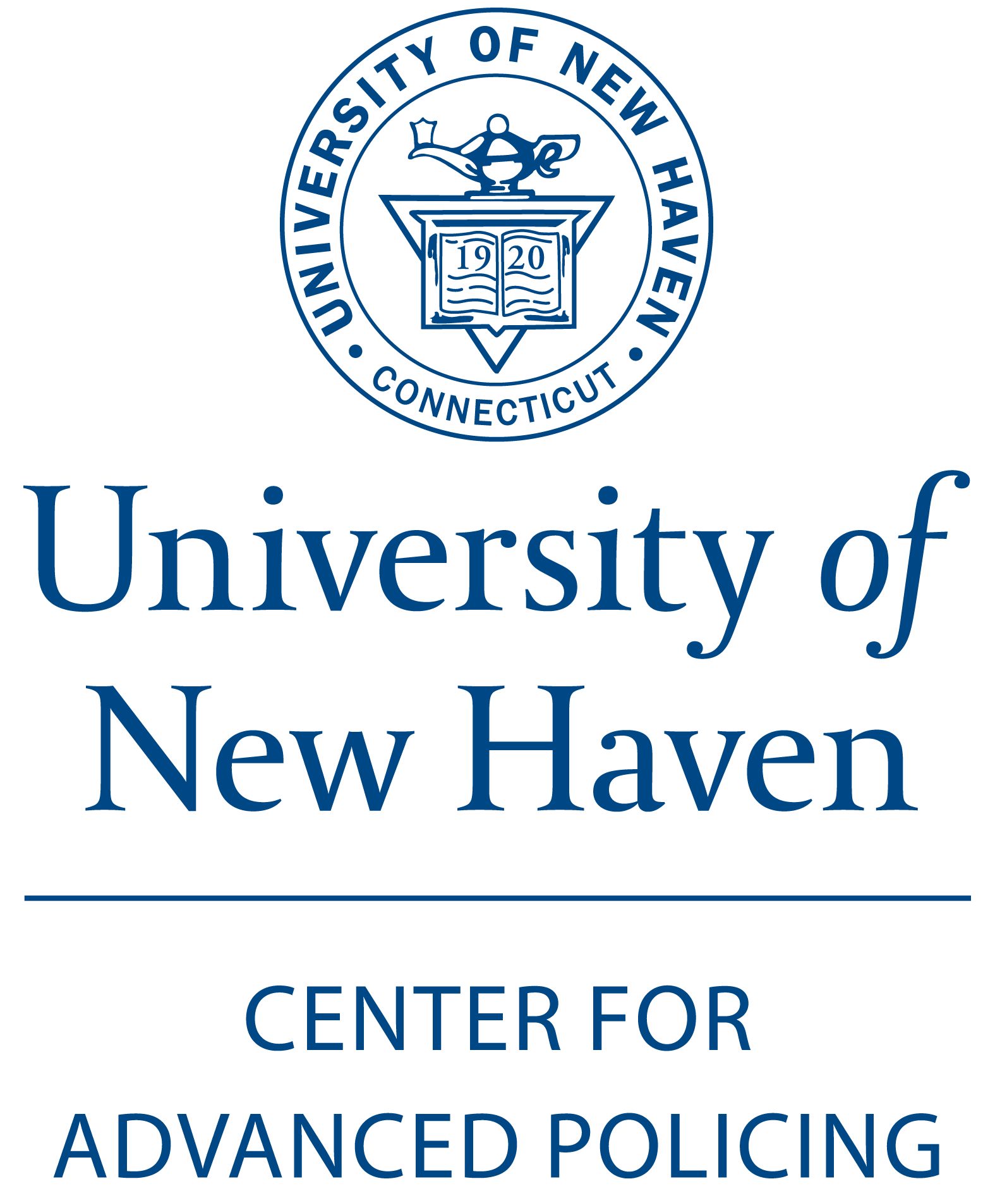
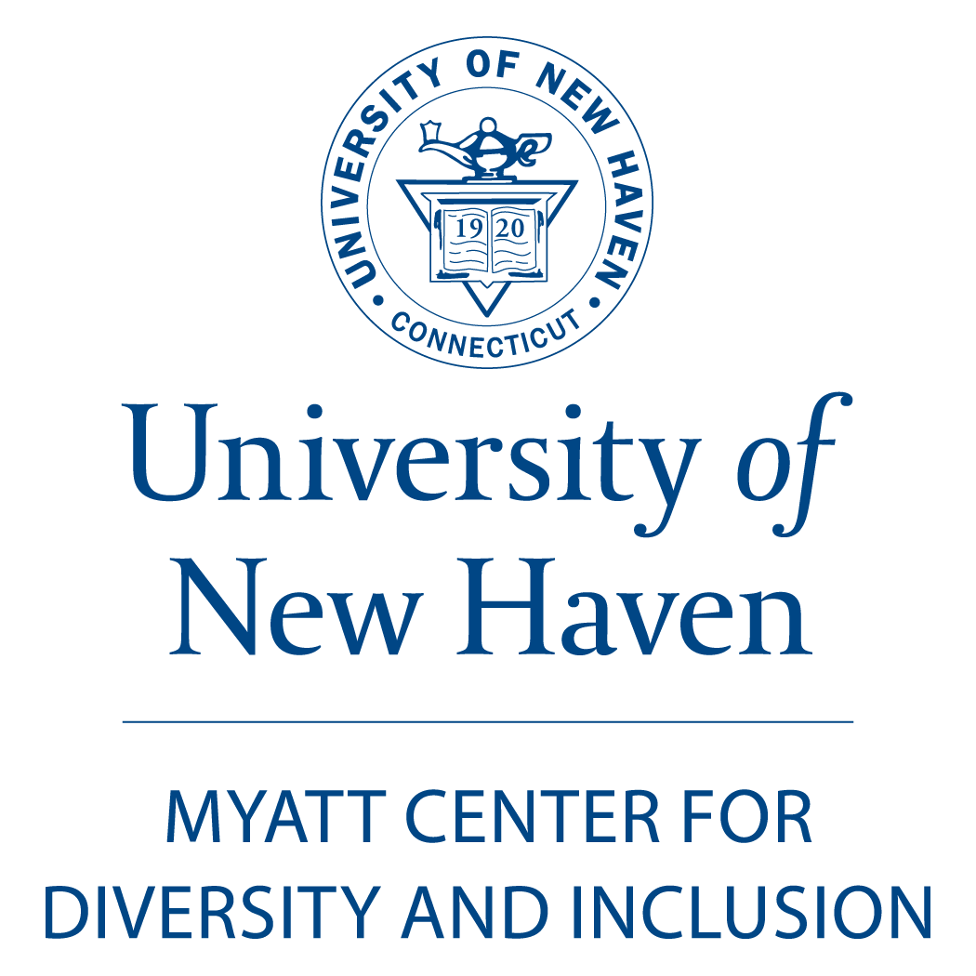
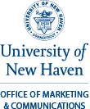

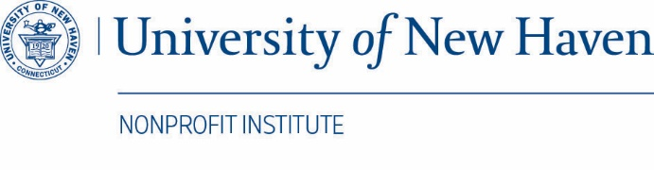
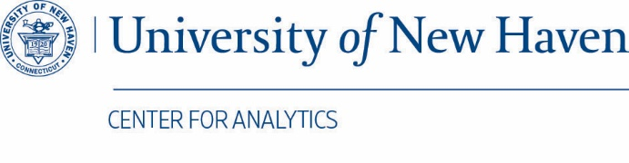

Juvenile Justice Policy and Oversight Committee


Achieving Positive Youth Outcomes Creating Safer and Healthier Communities
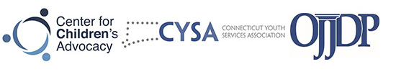

Addressing Racial and Ethnic Disparities through Local and Statewide Strategies
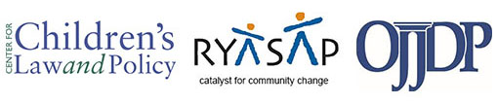

Transforming Youth Justice Program
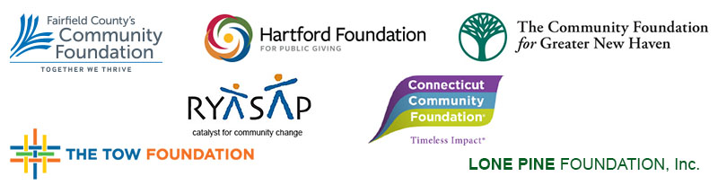

Connecticut Institute for Youth and Police Relations
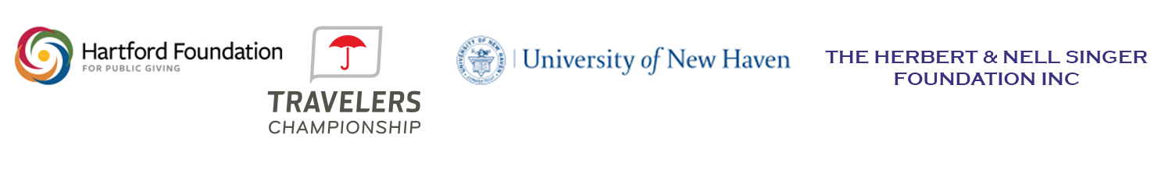

Restorative Practices Project
